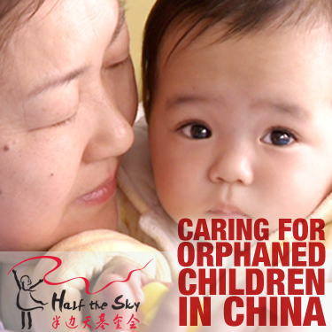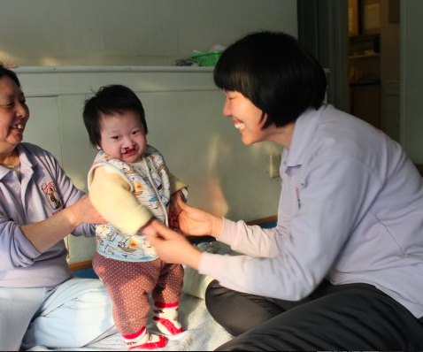

How to treat Cleft Lip/Palate

Treatment, Cost, Other information

About the Half the Sky Foundation

Goal, Information, and the Summer Program

Cleft Lip and Cleft Palate are craniofacial differences, or different facial structures. They are birth defects that occur when the bones in the face do not form properly. Cleft Lip is a split of the upper lip on one or both sides of the center. Cleft palate is a split in the roof of the mouth that results from an incomplete fusion of the palate. Cleft Lip and Cleft Palate can appear because of genetics. Some syndromes in the mother or father can cause the child’s tongue to be pushed back, creating the unusual formations of the mouth. However, there is only a 5% transmission rate of Cleft Lip/Palate from a parent to the child.

To Find Out How to Help- Go to Page

With Craniofacial Differences

Difficulties of Cleft Lip/Palate

Children

5.28.14

## What are Cleft Lip and Cleft Palate?

Inside

How to Help

Cleft Lip/Palate

5.28.14

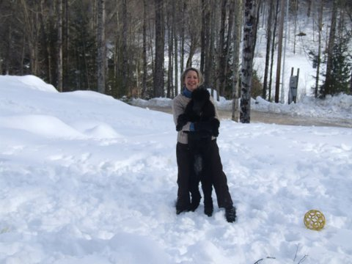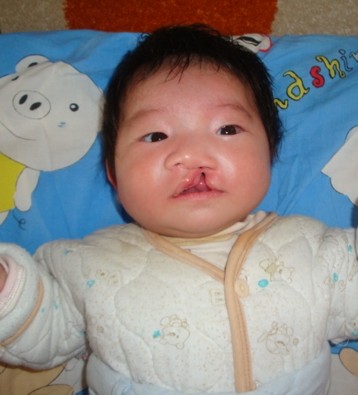

### Effects of Cleft Lip/Palate

The muscles in the palate enable a child to speak, eat/drink, and open & close the Eustachian tubes in their ears. For those children born with a Cleft Lip/Palate, these simple activities become challenging. They will have to eat and drink from a special bottle that requires no suction. The child will also have to go through speech therapy. There will be fluid in the ears because the Eustachian tubes equalize the pressure and create balance, causing many more problems with simple tasks, like walking. As a result, the child may develop ear infections. Furthermore, the child may be shunned and unaccepted by others, especially with the cultures of different countries. This is the reason why many children with Cleft Lip/Palate are orphans. Other cultures believe that the facial differences are punishments of God from the poor actions of their parents.

### Treatment

A child can be treated for Cleft Lip at 3 months of age, and for Cleft Palate at 6-18 months. Surgeons may insert ear tubes for 1-year-old children. If the child’s openings have disrupted the gum-line, a craniofacial team may do bone grafting on the child. However, not all hospitals are able to perform these life-changing surgeries. The cost of the operation varies according to who is performing, the extent of the work to be done, and the parents’ insurance plan. After corrective surgery, there is no long-term impact from having a Cleft Lip/Palate.

**Support**

The ACPA (American Cleft Palate Craniofacial Association) will be able to help if parents have any questions. The surgeons or nurses usually remain in contact with their patients until they become adults. In addition, through the process, parents form bonds with other parents to form a loving, caring community as they deal with similar issues. Volunteers may also offer support.

Meet Joan Rubin

a nurse at Saint Peter’s University Hospital

Joan Rubin has worked as a pediatric nurse for 30 years. She interacted with adults and children that have craniofacial differences. She is passionate about her job and absolutely loves everyone she works with.

The Half the Sky Foundation helps orphaned children in China that have a multitude of issues. Of these issues, Cleft Lip and Cleft Palate are the most common. It provides specialized caregivers that give the family-like love and care that all children need. The foundation gives the children new hope for a brighter future with medical care, education, and support. Teams all over the world help fund for these children who desperately need medical help. Previously, these children were unwanted because of their differences, the One Child Policy, gender preference, and their special needs. The Half the Sky Foundation has many “homes” which house the children pre- and post-surgery. There, they are cared for until they are adopted or are allowed to return to their previous institutions. Communities across America are involved in this foundation as well. For example, Bergen County Academies has had a China Care Club for many years and has helped raise money for the Half the Sky Foundation.

The Summer Program

The Half the Sky Foundation hosts a summer program every year that allows high school students to go to one of the orphanages in Beijing, China to volunteer and help these children. Students from Bergen County Academies have went on this trip, and many have been so impacted by it that they wrote their college essays on their experiences. The Half the Sky Foundation will plan where you will live, transportation, etc. For more information on this summer program, email [sarah@halfthesky.org](mailto:sarah@halfthesky.org).

##### Half the Sky Foundation

##### Helping Chinese orphans with medical needs

5.28.14

Cleft Lip/Palate

To find out more about the Half the Sky Foundation, go to its website: <http://halfthesky.org/en>

Vincent Ziccardi is a surgeon at the Rutgers University Hospital. He is a professor, program director, and chief of service at the hospital. Ziccardi works at the Rutgers University School of Dental Medicine (Formerly UMDNJ) as well. He has worked in this field since 1989, and has performed many surgeries regarding Cleft Lip and Cleft Palate. He also follows his patients until adulthood, seeing how the surgery has impacted their lives.

Vincent Ziccardi

DDS, MD, FACS

Your Child Being a Part of the Half the Sky Community

5.28.14

Cleft Lip/Palate

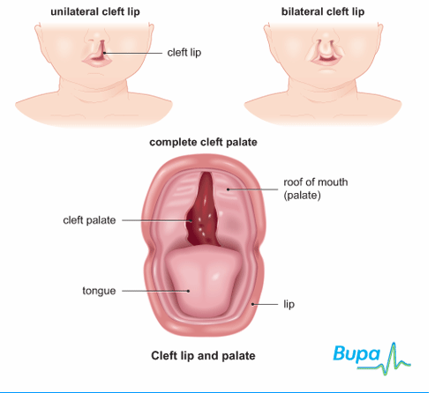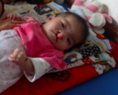

How to Help:

Directly Donate to the Half the Sky Foundation.

To sponsor a child, receive a certificate, and get updates on his/her progress, click on this link: <https://www.kintera.org/site/c.fwJUK9OZJnI8G/b.8072763/k.3852/Help_One_Child__Child_Sponsorship/apps/ka/sd/donor.asp?c=fwJUK9OZJnI8G&b=8072763&en=klJQJ4MRJjJSI4PXIiIRLaMYLvK7JcNMIfLYKhMXKnL4KkNaG&NumberOfPayments=11>

Purchase Items for the Children.

To buy items for the children to use, click on this link: <http://www.kintera.org/site/c.fwJUK9OZJnI8G/b.8072221/k.8C4F/Shop_to_Help.htm> You will be able to navigate through the prices and choose which items to donate.

Contact Me.

Feel free to call, text or email me for questions about anything! Look on page 5 for my contact information.

Your son/daughter can easily become a part of the Half the Sky community, and bring their school into it too! Not only will it benefit the children who need the funding and the help, but it will also benefit your child. Starting a China Care club is not easy, but your child will be able to gain many valuable experiences and skills. To start a China Care club, email [sarah@halfthesky.org](mailto:sarah@halfthesky.org). Your child will need to ask for permission from their school to start a new club or create a branch off of an existing club. For more information, click on this link: <http://halfthesky.org/en/chinacareclubs>. There are also many other volunteering options available other than creating a club. It also looks great on a college application!

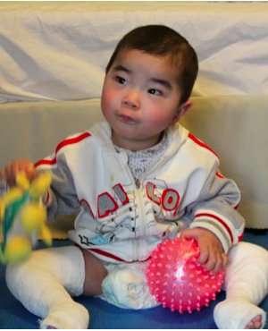

NanShan was born in Northern China with club feet, which meant that his feet were facing inward at his ankles. He couldn’t perform daily activities. Luckily, he got the funding from donors across the country through the Half the Sky Foundation for a surgery that clipped the Achilles tendons in both of his legs. His feet became allowed to move in the right position. NanShan also had a heart surgery. When he was recovering from these procedures, NanShan had to wear casts on both of his legs. But that didn’t affect his vibrant and playful personality. He played tons of games with his nannies and loved to giggle. After spending six months in Half the Sky’s China Care Home, NanShan went back to his former orphanage.

Meet NanShan

Want to help sponsor a child? See page 4

Cleft Lip/Palate

Treatment Centers in New Jersey

Cooper University Hospital

110 Marter Ave., Suite 402

Moorestown, NJ 08057

Phone: (856) 722-9110

Monmouth Medical Center

300 Second Ave.

Long Branch, NJ 07740-6565

Phone: (732) 923-7653

St. Barnabas Ambulatory Care Center

200 South Orange Ave.

Livingston, NJ 07039

Phone: (973) 322-7123

St. Peter’s University Hospital

254 Easton Ave., MOB 3rd Floor

New Brunswick, NJ 08901-1780

Phone: (732) 745-7943

St. Joseph’s Regional Medical Center

11 Getty Avenue

Paterson, NJ 07503

Phone: (973) 754-2924

University Hospital

150 Bergen Street

Newark, NJ 07103

Phone: (973) 972-1985

Back to Top

mwang734@gmail.com  
(201) 397-5582

and DONATE to the Half the Sky Foundation

Mary Wang

王恩溥

Contact me